“**Descriptive writing (people)**”

**Урок по английскому языку в 11-м классе (общеобразовательная школа: О.В.Афанасьева – Spotlight (Английский в фокусе).**

**Цель урока:**

Систематизировать и обобщить знания учащихся по теме “**Descriptive writing (people)**”, развивать навыки письменной речи и аудирования, использовать лексические единицы при описании внешности и характера человека.

**Objectives**

**Vocabulary:**physical appearance, character adjectives

**Listening**: a letter

*Skill –*listening and reading for detailed comprehension

**Reading**: an article describing a good friend (matching)

**Writing**: an article describing someone you admire

**Задачи урока:**

**Воспитательные:** воспитание толерантности к иноязычной культуре, применять теоретические знания на практике, развивать познавательный интерес к предмету, умение работать в коллективе, индивидуально, использовать практические знания в области информационных технологий с применением компьютера.

**Образовательные:** знакомить учащихся с возможностями использовать информационные технологии и навыки письма.

**Обучающие:**развитие навыков монологической речи, закрепить навыки произношения, прослушивание, чтения и перевода текста, семантизация лексических единиц в речи и письме, формирование языковой компетенции.

**Развивающие:** научить умению логически мыслить, развивать монологическую речь, закрепить умение наблюдать, сравнивать, сопоставлять, анализировать, оценивать других, умение работать индивидуально и в коллективе.

**Тип урока:** повторительно-обобщающий урок.

**Вид урока:** занятие-семинар.

**Оборудование:** компьютер, проектор, экран, CD с презентацией урока, карточки для индивидуальной работы, тесты для самостоятельной работы, учебники, тетради.

**Ход урока:**

I.​ **Инициализация урока.** (Слайд 1).

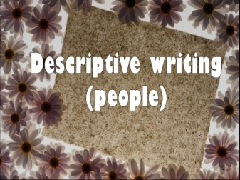

Приветствие учителя, краткое сообщение цели и задачи урока. Учащиеся записывают дату и тему урока **“Descriptive writing (people)”**в тетради.

**Teacher:**Good morning, students! Sit down, please. Sit up. Are you ready? Let’s begin our English lesson.

Today we shall speak about **“Descriptive writing (people)”**at our lesson. We’ll remember new words describing our friends, relatives, neighbours and different persons in letters and articles. We’ll listen to the text about Sunny to know about her personality and character. We’ll remember a lot of adjectives when we can speak about different people. I want you to practice writing skills.

Open your notebooks and write down the date and the theme of our lesson.

**Фонетическая зарядка**. (Слайд 2)

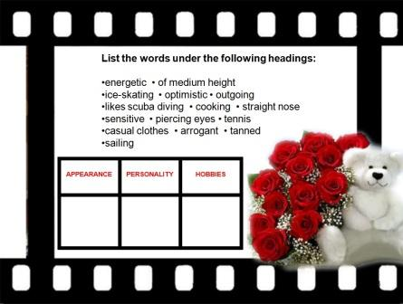

Take your print papers or look at the screen, you can see some words from our lesson and I want you to list them under the following headings. Be attentive in your pronunciation, please. Do it in writing.

Are you ready? Now it’s time to read.

-------------------------------------------------------------------------------------------------

Now open your textbooks at page 18, ex. 1 (the theory box). Let’s remember how we can describe the people in letters or articles.

Descriptions of \ Articles about people should consist of:

1.​ an **introduction**giving brief general information about the person **name / relationship to you & how / when you met him / her.**

2.​ a **main body** of two to four paragraphs describing the person’s physical appearance, personality and hobbies / interests / activities / achievements etc. in separate paragraphs. Start each paragraph with a topic sentence which summarises paragraph.

3.​ a **conclusion** with your comments & feelings about the person.

Description of people can be found in articles, letters, narratives etc. We use present tenses to describe someone we know well/see often **(*a relative, a good neighbour****)*and past tenses to describe someone who is no longer alive or who we don’t see any more ***(our best friend from primary school, a grandparent who has died)***.

(Слайд 3)

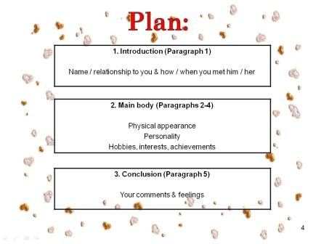

Now listen to the text as a model about the dearest friend Sunny. Match the headings to the paragraphs (Ex. 2a, p.18).

(Слайд 4)

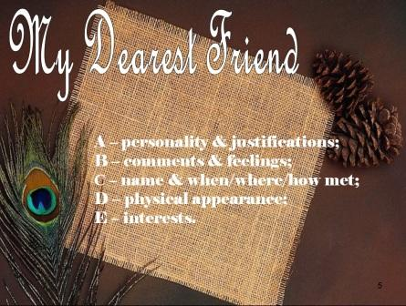

**Keys: 1-C; 2-D; 3-A; 4-E; 5-B.**

The recording is very slow, that’s why listen to it once:

My Dearest Friend

1.​ Sunny and I met on the first day of secondary school on a warm autumn day. After class I told her that her name described the weather perfectly that day. She laughed, and we became friends.

2.​ Sunny is an attractive girl in her late teens. She is tall, slender and dark-skinned and she usually wears her shoulder-length brown hair in a ponytail, which highlights her high cheekbones and long oval face. When she smiles, her almond-shaped eyes sparkle and her whole face lights up. She wears light makeup and fashionable clothes.

3.​ Sunny has an incredibly warm personality. She is supportive and knows how to encourage people when they’re feeling down. However, she tends to be very stubborn and determined. Once she’s made up her mind about something, no one can make her change it!

4.​ Sunny always lives life to the full. In fact, she finds it very difficult to sit still for long! She’s always humming her favourite songs, too, whatever she’s doing! She’s adventurous and loves discovering things about people and places.

5.​ Sunny is a marvellous friend who really lives up to her name. I find it hard to imagine what my life would be like if I hadn’t met her.

There are 5 paragraphs there. Please match the headings. (**Keys: 1-C; 2-D; 3-A; 4-E; 5-B)**

--------------------------------------------------------------------------------------------------------------

Now find words from the article in Ex.2 which match the headings describing Sunny. (Use Ex. 3a, p.18) or look at the screen.

(Слайд 5)

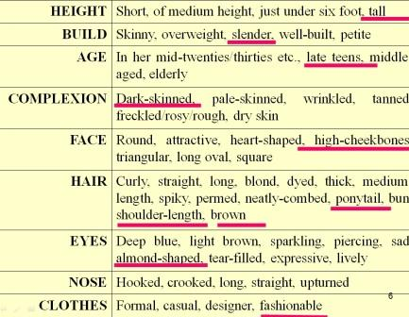

Now look at the photo of the teenager and use adjectives from the table to complete their descriptions. Use the example:

***Jane is quite good-looking. She’s slim with…and…hair. She’s pale-skinned with a…nose. She always looks well-dressed in…clothes.***

(Слайд 6)

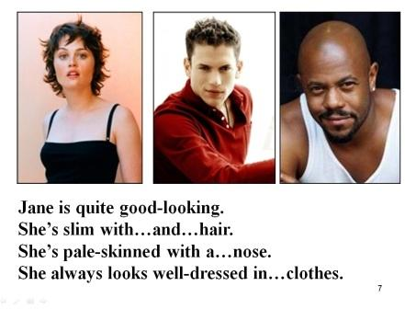

--------------------------------------------------------------------------------------------------------------------

Now I want to speak you about personality and behaviour.

(Слайд 7)

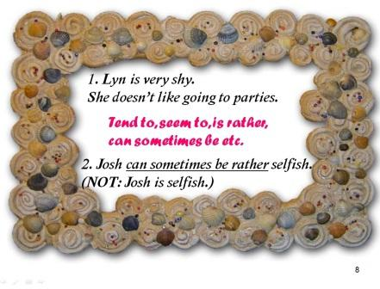

•​ When describing someone’s personality, use a variety of character adjectives and justify them with an explanation or example. *E.g.****Lyn is very shy. She doesn’t like going to parties.***

•​ If you describe negative qualities, use mild language. Use: **tend to,** **seem to, is rather, can sometimes be** etc. *E.g.****Josh can sometimes be rather selfish. (NOT: Josh is selfish.)***

Please translate from Russian into English and correct using the mild language (use phrases: *tend to, seem to, is rather, can sometimes be*etc.) (Ex.5, p.19):

(Слайд 8)



- Мой друг очень упрямый. (My friend is rather stubborn)

- Моя сестра всегда ведет себя по-детски. (My sister always behaves immaturely)

- Он ужасно неорганизован. (He is terribly disorganized)

---------------------------------------------------------------------------------------------------------------

Let’s relax.

(Слайд 9)



Guess who is this?

**Arnold Schwarzenegger**

He is well-built and just under six foot. Ha has got a big square face and straight nose. His hair is short and neatly-combed. He is athletic-looking because he is a former sportsman. He has large muscles. His eyes are green and piercing. His mouth is full of big teeth and he has a charming smile. He is in his middle-aged. He is an actor and a politician. He lives in the USA.

**Madonna**

She is of medium height. She has a strong sports body. Her face is round and pale-skinned. Her hair can be either curly or straight, either long or short because she has a changeable image. Her eyes are big and brown. Her nose is straight. She prefers fashionable clothing. She can often be seen at the stage singing and dancing. She took part in some movies. She has 2 children: a daughter and a son. Now she is divorced. Her hobby is yoga.

(Слайд 10)



Open your textbook at page 19, Ex.4a. Match the adjectives to their justifications.

1. ***energetic 2. easy-going 3. talkative 4. lazy 5. bossy 6. optimistic 7. ambitious 8. selfish***

9.***hot-tempered 10. Popular***

(Слайд 11)

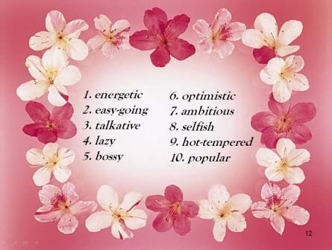

a. always looks on the bright side of life

b. never stops chatting

c. is always telling people what to do

d. only cares about him/herself

e. is always on the go

f. has lots of friends and is liked by everyone

g. isn’t easily annoyed, worried or upset

h. doesn’t like working

i. has a strong desire to be successful in life

j. gets angry really easily

-----------------------------------------------------------------------------------------------------------------/

Now let’s do the test using the adjectives. Fill them in the sentences. Write down your answers in the notebooks. (Ex. 4b, p.19):

1.​ ***aggressive 2. pessimistic 3. generous 4. hard-working 5. outgoing 6. arrogant***

***7. sensitive 8. cheerful***

1.​ Ben is so… . He believes that a job isn’t worth doing unless it’s done properly.

2.​ Alison is quite… .She often picks fights with people and gets angry really easily.

3.​ Jake is … . He’s the life and soul of the party and loves meeting new people.

4.​ Joe is a… person. He always expects the worst.

5.​ Tanya is… . She’s always got a smile on her face and never lets anything get her down.

6.​ I’ve never met anyone as…as Sally. She’s always buying people gifts.

7.​ John is so…! He thinks he’s more important and better than everyone else.

8.​ Sam is a…guy. He’s a great listener and seems to understand when you’re feeling down.

**Keys: 1-hard-working, 2-aggressive, 3-outgoing, 4-pessimistic, 5-cheerful, 6-generous, 7-arrogant, 8-sensitive.**

-------------------------------------------------------------------------------------------------------------------

(Слайд 12)

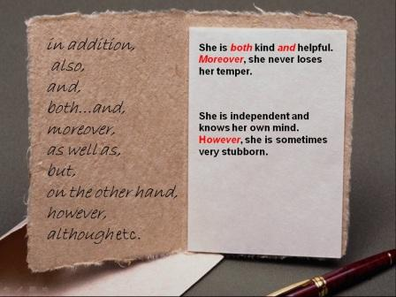

Sometimes you can join descriptions of **similar** personal qualities and of **contrasting** ones by using: *in addition, also, and, both…and, moreover, as well as, but, on the other hand, however, although*etc.

For example: **She is *both* kind *and*helpful. *Moreover*, she never loses her temper. Or: She is independent and knows her own mind. H*owever*, she is sometimes very stubborn.**

Take your print papers, Ex. 2. Rewrite the sentences using linking words or phrases.

--------------------------------------------------------------------------------------------------------------------

(Слайд 13)

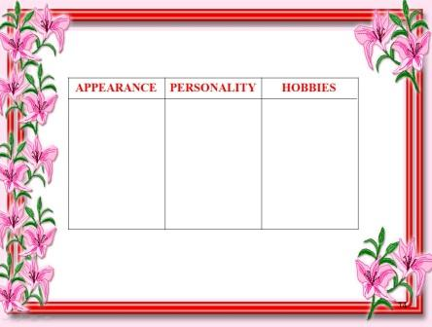

Two students are ready to deliver their family describing personal qualities. Let’s start.

Students, what words and phrases did they use describing their families?:

**Подведение итога урока.**

I am going to sum up. Today we spoke about **“Descriptive writing (people)”**at our lesson. We knew new words describing different persons. We listened to the tape about Sunny to know about her personality and character and practiced writing skills. Also you answered my questions and saw a computer presentation. I think our English lesson was full of information which you can use in your other school ones.

**Домашнее задание.**

(Слайд 14)

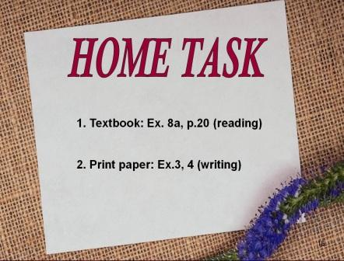

I want you to write down your home task in your diaries.

Read the theory box at p. 20, Ex. 8a. When describing a person, we can use our senses (sight, sound, smell, taste, touch) and then do Ex. 3 in your print papers and rewrite the sentences as a model. Ex. 4 – Read the following essay and put the paragraphs in the correct order using our plan to describe people.

**Выставление оценок.**

Now your marks.

**Завершение урока и прощание.**

The lesson is over. I thank you for your pleasant lesson. Good bye!

*By Amina Alieva*

*School No. 2,*