***Задачи урока:***

* Дать визуальное представление о достопримечательностях столицы Британии.
* Научить ориентироваться в городе по плану, карте.
* Способствовать развитию творческих способностей учащихся
* Обучать монологическому высказыванию

***Цели урока:***

* Формировать социокультурную компетенцию сквозь призму восприятия достопримечательностей Лондона, как достояния Британской культуры.
* Формирование навыков чтения и говорения.

***Оборудование: карточки ,карта Лондона,*** **персональные компьютеры**.

**Учебные материалы:Компьютерная презентация всех этапов урока**.

Ход урока:

*1)этап урока -* ***Организационное начало урока:***

***Good morning,******Good morning,***

***Good morning to you, good morning***

***Good morning, we are glad to see you!***

*What is the date today?*

*Is it windy today?*

*What is the day of week today?*

*Is it cloudy today?*

*Is it sunny today?*

*What season is it now?*

**2) этап урока – введение в тему урока**

– Let’s remember the poem “Little girl”. Look at the board and repeat after me

P1, P2, P3

– Today we are going to learn more about London. London is famous for its poets. One of the most famous poets is Oscard Wild. Listen to the poem.

В сопровождении звучит музыка, придающая эмоциональный окрас стихотворению.

**“Impressions du Matin”**

The Thames nocturne of blue and gold   
Changed to a harmony in grey:  
A barge of ochre-coloured hay  
Dropt from the Warf: and chill and cold.   
The yellow fog came creeping down   
The bridges, till the houses walls  
Seemed changed to shadows and St. Paul’s  
Loomed like a bubble o`er the town.

– Listen to the translation of this poem.

**Утро**

Ноктюрн уснувшей Темзы, сине-золотой  
Аккорды пепельно-жемчужные сменили,  
Тяжелый бот проплыл над сонную водой,   
И тени дрогнули, безвольно отступили  
Клубами мутными сползал в реку туман,   
Домов неясные вставали очертанья.  
Рассвет задул огни … Но чудился обман  
И медлил бледный день вернуться из изгнанья.

В. Эльснер

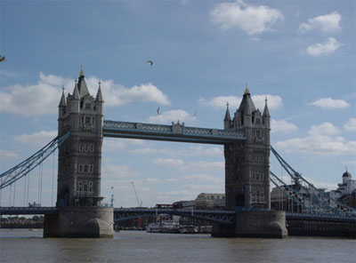

– Answer my questions:

1. Do you like this poem?  
2. Is it beautiful?  
3. Is this poem about the Thames?  
5. Where is the Thames situated?  
6. Have you ever been to London?  
7. Do you want to go to London?

– Your dream is real. Today we are going to travel there by train.

**3) этап урока - Лексическая разминка.**

Find  words and places of interest in London:

|  |  |  |  |  |  |  |  |  |  |  |  |  |  |  |  |
| --- | --- | --- | --- | --- | --- | --- | --- | --- | --- | --- | --- | --- | --- | --- | --- |
| T | R | A | F | A | L | G | A | R | S | Q | U | A | R | E | H |
| F | Q | H | J | B | B | C | S | B | B | S | B | N | M | W | E |
| B | U | C | K | I | N | G | H | A | M | P | A | L | A | C | E |
| W | E | E | R | G | T | Y | Y | Y | O | U | I | O | O | F | F |
| D | E | F | D | B | V | B | D | T | M | H | B | N | V | C | X |
| X | N | C | V | E | C | F | E | A | I | A | S | D | D | F | G |
| I | O | L | K | N | J | H | P | G | F | D | T | O | W | E | R |
| S | D | F | F | G | T | H | A | M | E | S | F | N | D | S | C |
| B | N | N | G | H | J | A | R | R | H | J | N | Z | B | V | C |
| C | V | B | N | M | I | U | K | Y | T | R | R | O | E | W | S |
| S | H | A | K | E | S | P | E | A | R | E | R | O | E | W | Q |

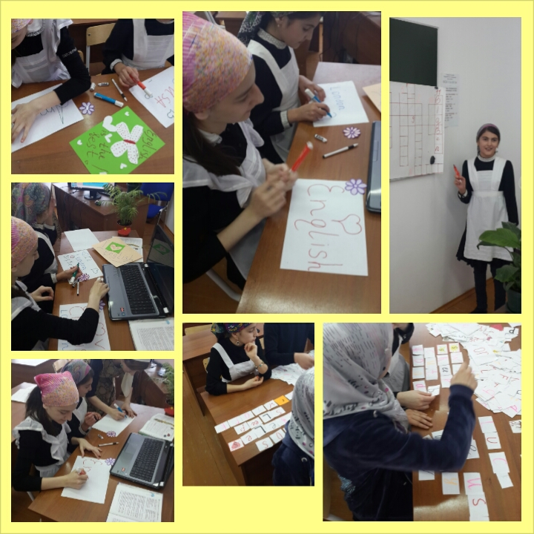

Keys: Trafalgar Square, Buckingham Palace, MOMI, Big Ben, Queen, Thames, Tower, Shakespeare, Hyde  Park, London Zoo.

Ученики выполняют задание на индивидуальных карточках, а затем проговаривают слова, найденные в задании , сверяя друг с другом.

**4) Введение нового материала**

**А)The places of interest**

**Trafalgar Square** is the centre of London. It is the most beautiful place of London. There is the monument of Admiral Nelson. Four bronze lions look at the square from the monument. There are two beautiful fountains in the square.

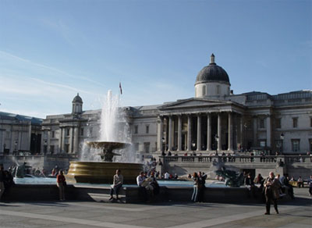

Trafalgar Square

**The National Gallery** is one of the best picture galleries of the world. Every day many tourists visit this fine building with tall columns.

The large clock in one of the towers is **Big Ben.** You can hear the sound of Big Ben every hour in London. The clock and the bell got there names after Sir Benjamin Hall. He was a tall man and his nickname was Big Ben.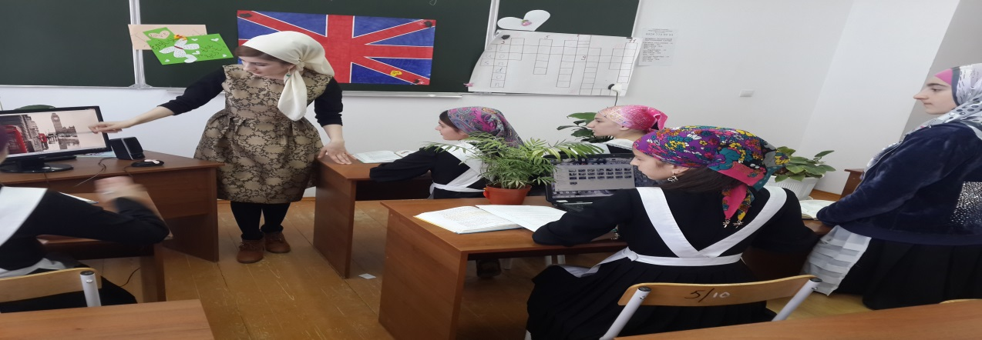

**Buckingham Palace** is the official residence of the Queen of England. The ceremony of changing the Guard takes place in front of the Palace daily from April to August.

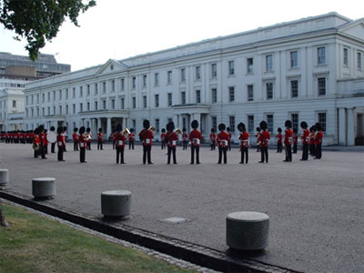

Buckingham Palace

**The Tower of London** was used as a fortress, a royal residence, a palace, a prison and the King’s zoo. Now it is a museum of amour and also the place where the Crown Jewels are kept. There are always black ravens in the Tower of London. People keep them in the Tower and look after them very well as they believe that London will be rich while the ravens live there.

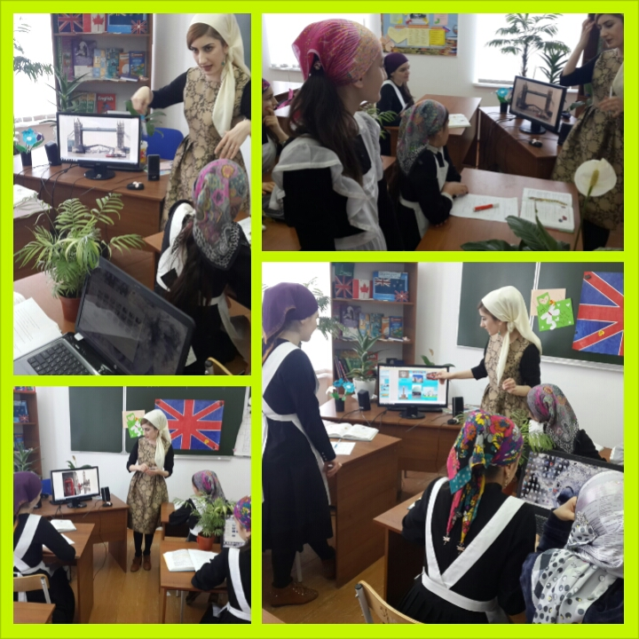

the Tower of London

– And we are going tо the first place of interest in London; it is “Trafalgar Square”   
– Our next station is “The National Gallery”   
– Now it is “Big Ben”  
– Look here please! You can see “Buckingham Palace”   
– The Tower of London is in front of you.

***B) (ученики выполняют мини-тест)***

***Лексический тест Match:***

|  |  |
| --- | --- |
| 1) The Tower of London | a) Колонна Адмиралу Нельсону |
| 2) Westminster Abbey | b) Лондонский мост |
| 3) London Bridge | c) Замок Тауэр |
| 4) Sherlock Holmes’s House | d) Вестминстерское Аббатство |
| 5) Madame Tussaud’s | e) Башня Биг Бен |
| 6) Big Ben | f) Музей восковых фигур |
| 7) The London Planetarium | g) Дом – музей Шерлока Холмса |
| 8) Nelson’s column | h) Лондонский планетарий |

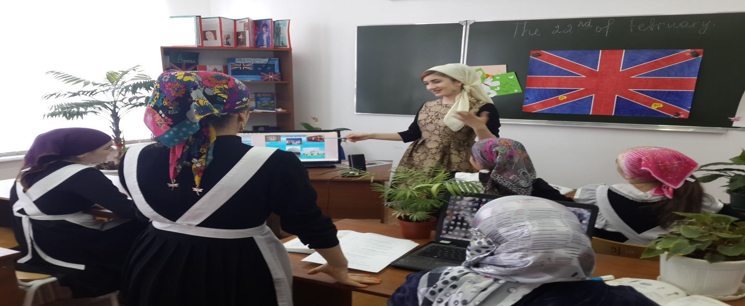

C) Совершенствование навыков чтения. Чтение текста с извлечением требуемой информации.  
На экране карта Лондона.

Now, well read the text which you have prepared at home. After that you will do the task True or False. Be attentive, please. Who wants to start?  
Учащиеся друг за другом читают текст из книги This is London by Philip Prowse.

На экране задание True False.

1. Many tourists go by helicopter along the River Thames.  
2. The Royal Festival Hall and the Tate Modern are on the north Bank.  
3. The London Eye is the best way to see the whole city.  
4. The Gherkin looks like an apple.  
5. Wharf is a new centre of business in London.  
6. The Houses of Parliament are the centre of the British Government.  
7. People call the tall clock tower Big Ben.  
8. The Prime Minister lives in number 1 Downing Street.  
  
And now look at the places you have just read about.   
Lets divide into two groups. The group which score is better will be the winner.  
На экране фотографии с изображениями тех мест, о которых читали учащиеся.  
  
  
4) Постановка вопросов.  
Now take these sheets of paper. Be ready to make up questions to the answers given to you. Write them down. Dont forget about the order of the words. Work in pairs.  
Ученики получают листочки с ответами и задают соответствующие вопросы, записывают их. Если есть ошибки исправляем вместе.

**5) Этап урока – Физкультминутка (Have a rest)**

– Stand up please. Up, down, up, down. *(руки вверх, вниз)*

Which is the way to London Town? *(шагаем на месте)*

Where? Where? *(руку к глазам, повороты влево, вправо)*

Up in the air, *(смотрим вверх)*

Close your eyes *(закрываем глаза)*

And you are there!*(разводим руки в стороны)*

6)Музыкальная минутка

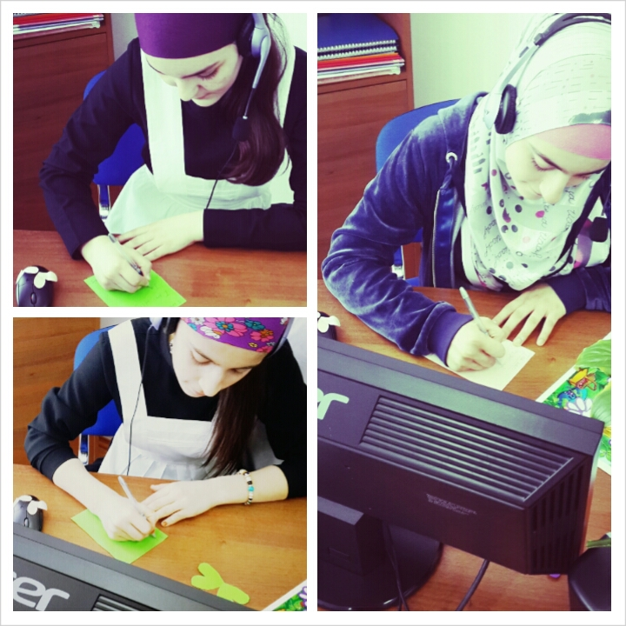

(учащиеся слушают и переводят песни с английского на русский язык)

**7)Рефлексия**

Учащиеся записывают в тетради свои предложения об увиденном на уроке с помощью вопросов, записанных на доске.

Look at the blackboard and write sentences in your exercise-books.

-What places of interest would you like to visit?

-What can you see above Buckingham Palace?

-What have you learnt at the lesson?

-What was the most interesting for you?

-What was the most difficult?

**8)Заключительный этап урока**

* Did we read ?
* Did we do exercises ?
* Did we play?
* Do you like today’s lesson?
* I like your work at the lesson.

-T:  I like that you were very active today. Your marks are …..

-T: The lesson is over , you may go .